**1. Create a database MOVIE_DATABASE, In MOVIE_DATABASE**

**a) Create a table MOVIE with below columns**

**Movie_ID with ϐixed length of 5**

**Movie_Name with variable length of 50**

**Type to store the type of movie with variable length of 20**

**Release_Date to store the release date.**

**Production_cost as integer to store the production cost in dollar.**

**Collection as integer to store the total collection in dollar.**

**Review as of type variable length string of 200, make the column to not allow null values**

**b) After creating table make movie_id as primary key**

**c) Delete the column review of the table.**

**d) Insert values in the Movie table to make table look below table.**

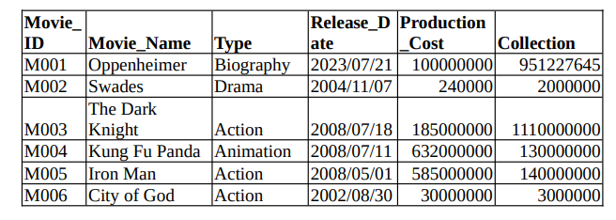

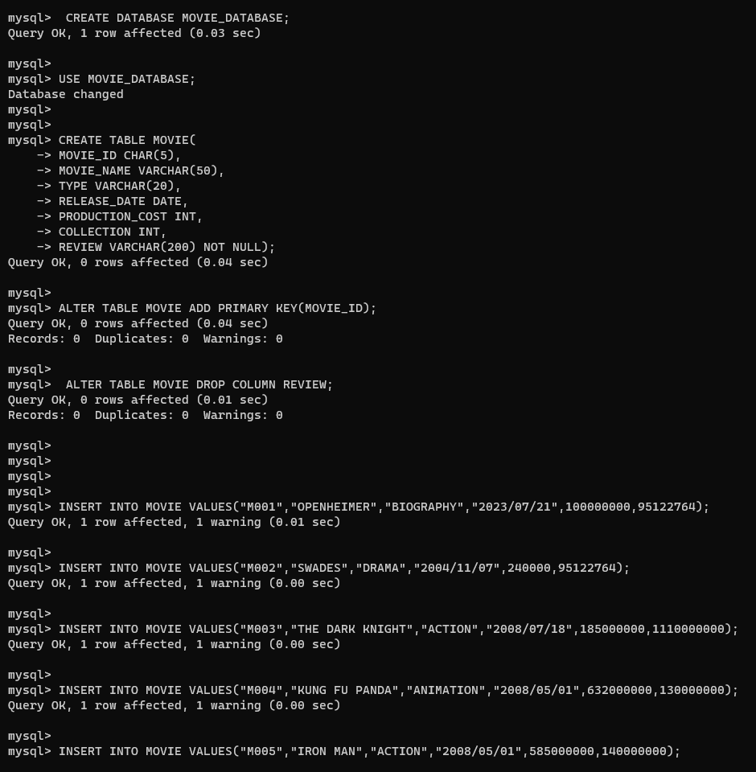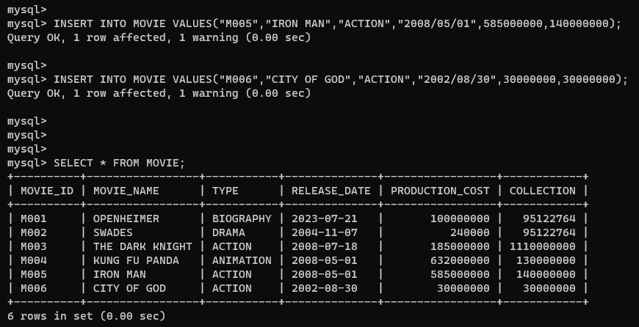

**2. Consider the MOVIE table and write the SQL queries based on it.**

**i. Display all information from movie.**

**ii. Display the type of movies.**

**iii. Display movieid, moviename, total_earning by showing the business done by the**

**movies. Calculate the proϐit earned by movie using the difference of collection and**

**production cost.**

**iv. Display movieid, moviename and productioncost for all movies with productioncost**

**greater than 135,000,000 and less than 960,000,000 .**

**v. Display the movie of type action and drama.**

**vi. Display the list of movies which released in ,May and July of year 2008.**



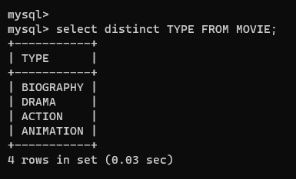

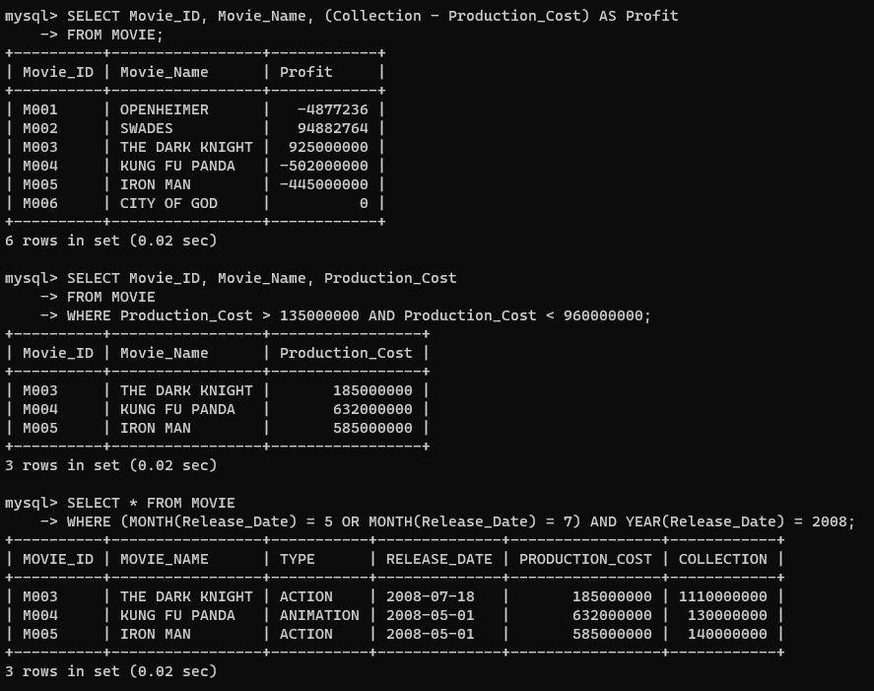

**3.Consider the Movie table and write query based on it.**

**i. Display the Year and maximum collection done among all the movies in that year.**

**ii. Display type of the movie and total production cost of those types.**

**iii. Display the year and total movie released in those years.**

**iv. Display the maximum collection done by any movie in the database**

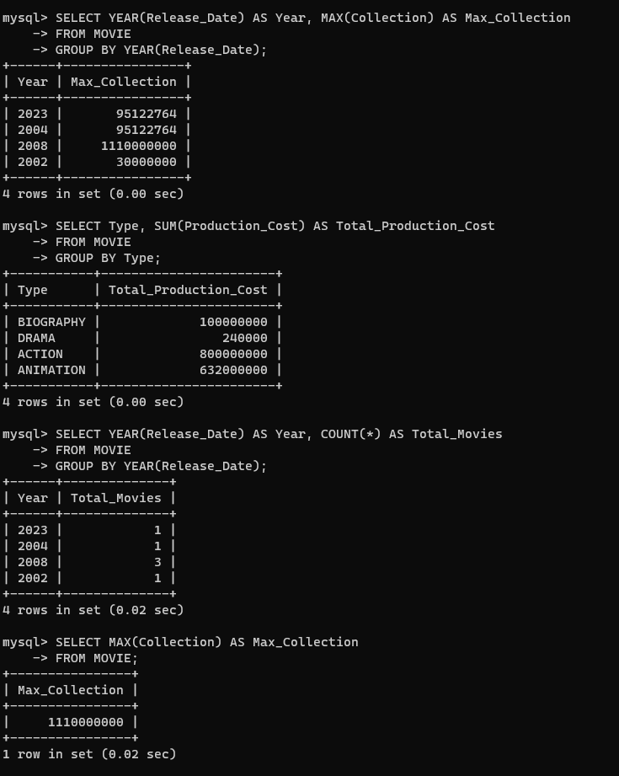

**4. Consider the movie table and write query based on it.**

**i. Change the movie_id of the all movies in lower case and which were released in**

**year 2008**

**ii. Insert any new upcoming movie details in a new row providing all required**

**values, this movie has not yet any collection value.**

**Iii. Change the Collection column of all the movies to 100000 where collection is**

**null**

**iv. Delete all the movies whose name ends with ‘a’ and were released in 2008.**

